**Analyzing the Impact of Restaurant Features on Customer Ratings: A Machine Learning Approach.**

Mohammad Khaki1, Fereshteh Dehghani1,*

1. Department of computer engineering, University of Kashan, Kashan, Iran

*Corresponding Author:

Address: Kashan

Tel/Fax: +98

Email:

**Abstract**

With the growth of social networks, there is an abundance of information available to aid in decision-making. This study, analyzed various aspects of restaurants to determine their impact on overall customer ratings. Utilized restaurant data from Zomato to assist users in identifying their preferred dining options in unfamiliar cities. The analysis focused on eight features divided into two groups: "quality and price" and "delivery." The random forest algorithm was employed to generate scores based on both new and previous data. The proposed method was effective in accurately ranking recently opened restaurants with minimal customer feedback, with a ranking accuracy of 71%.

The data was preprocessed to normalize numerical data and remove redundant and outlier data before unsupervised learning methods such as k-means and hierarchical clustering were utilized to generate new parameters. In order to increase the number of samples, oversampling was employed. Feature selection methods were then used to choose the six parameters out of the initial ten that had the highest correlations. The aggregate rating was used as the label in the supervised learning algorithm, alongside the six selected parameters, to predict the ratings of a given set of restaurants.

Furthermore, this paper highlights the use of machine learning techniques in assisting restaurants in enhancing their customer service by prioritizing influential parameters. The outcomes of this research demonstrate the potential for machine learning to improve the restaurant industry and aid in the selection of dining options for customers.

**Keywords**: Machine Learning - Random Forest - Restaurant – Clustering – Customer ratings – Predictive modeling

# Introduction

With the increase of web-based applications and ease of use on smartphones, online orders for essential goods are on the rise. Therefore, with the increase in web-based applications and the ease of use of smartphones, internet orders for essential goods are on the rise. Therefore, it is necessary for business owners that users have the same experience of online shopping as face-to-face shopping. Today one of these online services that is receiving much attention is the food preparation service. It is necessary for business owners that users have the same experience in online shopping as face-to-face shopping. Today one of these online services that have been paid much attention to is the food preparation service.

Automated recommender systems have revolutionized how content and business are marketed and delivered by making personalized suggestions and predictions about a wide range of large and complicated products [1]. Eventually, the existence of a criterion can help diagnose scores out of the predicted range and omit cheaters [2]. The criteria used in this paper are based on quality, price, and delivery services. However, more parameters must be considered to make the intelligent system algorithm work more effectively. According to [3], the service speed, food volume, lighting, and atmosphere of the room affect the performance. However, with the spread of the Covid-19 disease, most people stayed home and ordered their food online rather than going out, and recent years have seen an increase in the number of people ordering food online [4]. Furthermore, marketing is known to help collections grow, and one of the crucial components of marketing is studying and improving users' social influence on food applications [4]. Nowadays, restaurant classification has become increasingly important for people and businesses using the Internet to expand services [5].

Before dining out, people search websites and apps for local restaurants and choose one based on an average score. Generally, It is impossible to predict the quality or cleanliness of a restaurant by its average score. The use of personalized recommendation systems is prevalent in many online firms to improve the user experience by recognizing user preferences and suggesting relevant products. Classifying restaurants by topic facilitates creating a recommender system in machine learning [6].

In this paper, machine learning techniques are used to predict how restaurants will score, and each restaurant is ranked based on food quality, price, online ordering, and delivery service. This lets us guess how people will rate a new restaurant that has not been rated by many people yet.

# Related work

Some previous works have shown that restaurant customers care about the quality of the food as well as how satisfied they are with online food delivery applications [7-11].

The characteristics of customer satisfaction with restaurant delivery applications are identified in Korea. The results showed that mobility and reliability affected satisfaction and loyalty. Therefore, developers should focus on making them more dynamic and trustworthy rather than adding more information to food delivery applications [12].

|  |  |  |  |  |
| --- | --- | --- | --- | --- |
| Ref No | Aim of paper | Methodology | Dataset | Main Conclusion |
| [12] | Data summary | Analyze structural equation modeling | Questionnaire in Korea | Application developers should not now focus on presenting an enormous amount of information to users |
| [5] | Multi-labeling before classification | Support vector machine | Zomato | Classy ambiance and delivery service are two criteria for classifying restaurants. |
| [13] | Feature prioritization | Analyze structural equation modeling | Questionnaire in Iran | The quality of the meal has the greatest impact on customer satisfaction. |
| [2] | Effectiveness of dummy scores and unfair scoring | Rev2 | OTC, Alpha, Amazon, Flipkart, and Epinions | to identify dishonest users, three quality metrics are used: fairness of users, evaluation of the quality of products, and reliability of ratings. |
| [14] | Suggest a classifier | Naive Bayes, Support vector machine | Open Rice | The accuracy of a classification system is influenced by the relationship between the classification models and the feature options |
| [15] | Analyze restaurants on user behavior | Recommender system | Yelp | It is effective to classify users according to their location and behavior |

A multi-label classification method was used to classify restaurants based on predefined features affecting ratings [5]. In this work, using the outputs of two classifiers applied to a different set of features, two labels, that is, delivery service and classy ambiance, are suggested for each instance by support vector machine (SVM) classification. In addition, each class is assigned an integer number ranging from 1 to 5, and the dataset is Zomato. The proposed multi-label model, however, classifies instances with an accuracy of about 80% in classes without online delivery. Therefore, users receive a subset of accepted restaurants that meet their needs via the proposed method.

# THE PROPOSED METHOD

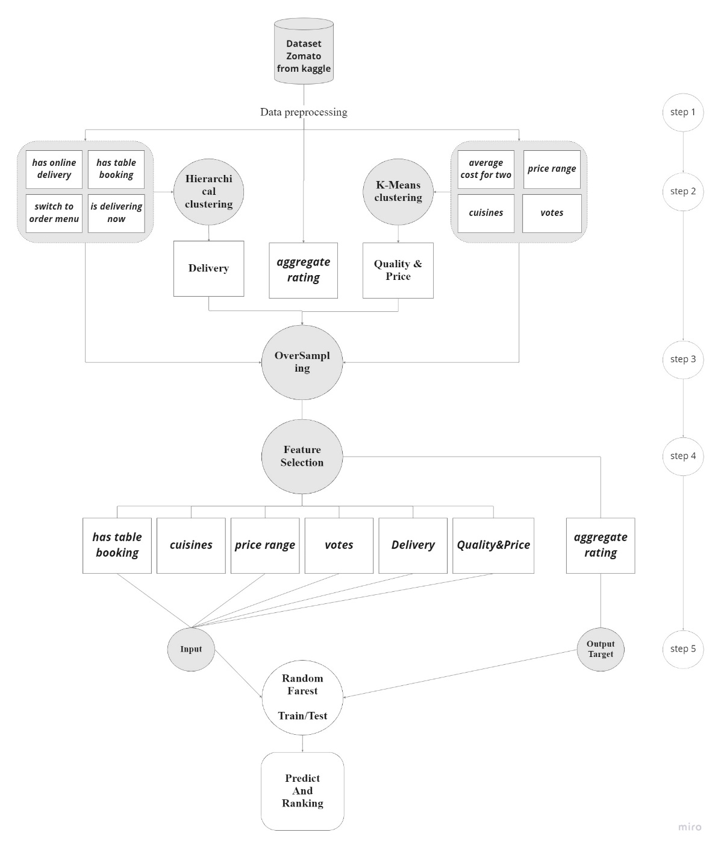This section explains the proposed classification method. In this paper, data clustering is used for extracting additional features to enhance the performance of classification techniques by exposing the hidden structure of input data. As shown in Fig. 1, the proposed framework consists of five steps: data preprocessing, creating an augmented dataset by data clustering, oversampling, feature selection, and classification. They are described in the following subsections.

Figure . The Process Predict Model

## Data preprocessing

The Zomato data set [16], containing features of various restaurants, is selected in this paper, and some features are selected and converted as follows. An overview of the selected features is presented in Table 1, including their name, description, and type:

1. Select only the required features tabulated in Table 1 and disregard others such as restaurant name, city, and address. The details of selected dataset features are summarized in Table 1
2. Unify the units of the "Average cost for two" feature to dollars because of the difference of currency units.
3. Replace the string value "Cuisines" with an integer value representing the number of food types.
4. Round the multinomial values of the "Aggregate rating" feature to integers 1 and 5 to use them as inputs for Random Forest classification. The following rules are applied instead of rounding to the nearest integer to maintain the semantic distinction:

* If Aggregate rating ≥ 4.5, then "5".
* If 4.5 ≥ Aggregate rating ≥ 3.8, then "4".
* If 3.8 ≥ Aggregate rating ≥ 2.8, then "3".
* If 2.8 ≥ Aggregate rating ≥ 1.8, then "2".
* If 1.8 ≥ Aggregate rating, then "1".

1. Normalize numeric features to the standard range because of their different scales. A min-max normalization is performed on the input values to scale them between zero and one, as shown in Equation 1.

Equation

Table . Parameters of Dataset

|  |  |  |  |  |
| --- | --- | --- | --- | --- |
| Clustering method | Decision label | Feature name | Description | Type |
| Hierarchical | **Delivery**  **(G1)** | **Has online delivery** | online order | binary |
| **Has table booking** | Online booking table | binary |
| **Is delivering now** | Ability to send food | binary |
| **Switch to order menu** | Availability of food menu | binary |
| K-means | **Quality and Price**  **(G2)** | **Cuisines** | Food diversity | string |
| **Average cost for two** | The average cost for two people | number |
| **Price range** | Range of food Price | number |
| **Votes** | Number of comments | number |
| Response label | | **Aggregate rating** | Average user votes | decimal number |
| Auxiliary convert feature | | **Currency** | Currency | string |

## Feature extraction based on clustering

In order to improve the quality of classifications, data clustering can be used. This theory is based on the following simple concepts: (1) grouping the training examples into clusters, (2) encoding the clusters as new features, and (3) obtaining predictions using the model that has been trained. For any classifier to be able to learn, it is assumed that classes in the dataset reflect its structure. However, this assumption may not be true in every case. Thus, it is tempting to investigate whether the use of clustering could aid the classification process by identifying the inherent, "true" structure of the dataset. Generally, if both structures (i.e., those revealed by clustering and those implied by classes) map perfectly to one another, the dataset can be classified easily. Otherwise, attributes conveying this "hidden" structure of data by clustering can contribute to better generalization of classification models [17].

A summary of selected dataset features is presented in Table 1. The following section summarizes the features that are used in unsupervised learning clustering approaches. The clustering results of hierarchical and K-means methods, referred to as "delivery-G1" and "quality-G2" respectively, are used as new features for classification in the following step. Based on the type of features in the input data, the data is divided into two groups as shown in Figure 1 [5]:

1. For the hierarchical clustering approach, the selected features are as a first group: "Has online delivery", "Has table booking", "Is delivering now", and "Switch to order menu".
2. For the K-means approach, the selected features are as a second group: "Cuisines", "Average cost for two", "Price range", and "Vote".

Finally, the clustering results and the basic features are combined as the input of feature selection algorithms to improve classification results [17]. A detailed explanation of the two clustering methods is provided in the following.

The Hierarchical and K-means clustering approaches are discussed in this section.

### Hierarchical cluster

Using a process called "divisive hierarchical clustering," a "binary merge tree" is made from the root up to the leaves, which hold data elements [18].

According to Figure 2, since manufacturer parameters of Delivery-G1 are binary, values are assigned based on their presence or absence.

The tree was created according to the parameters correlation coefficient with Aggregate Rating, so Has table booking is at the tree's root.(ترجمه فارسی در کامنت)

* If all variables were zero, then the tree's leaf would be 1.
* If "Has table booking" was zero and "Has online delivery" was zero, and one of "Delivering now" or "Switch to menu" was one, then the leaf of the tree would be 2.
* If "Has table booking" was zero and "Has online delivery" was one, and "Delivering now" was zero, then the leaf of the tree would be 2.
* If "Has table booking" was zero and "Has online delivery" was one, and "Delivering now" was one, then the leaf of the tree would be 3.
* If "Has table booking" was one and "Has online delivery" was zero, and "Delivering now" was zero, then the leaf of the tree would be 3.
* If "Has table booking" was one and "Has online delivery" was zero, and "Delivering now" was one, then the leaf of the tree would be 4.
* If "Has table booking" was one and "Has online delivery" was one and one of "Delivering now" or "Switch to menu" was zero, then the leaf of the tree would be 4.
* If all variables were one, then the tree's leaf would be 5.

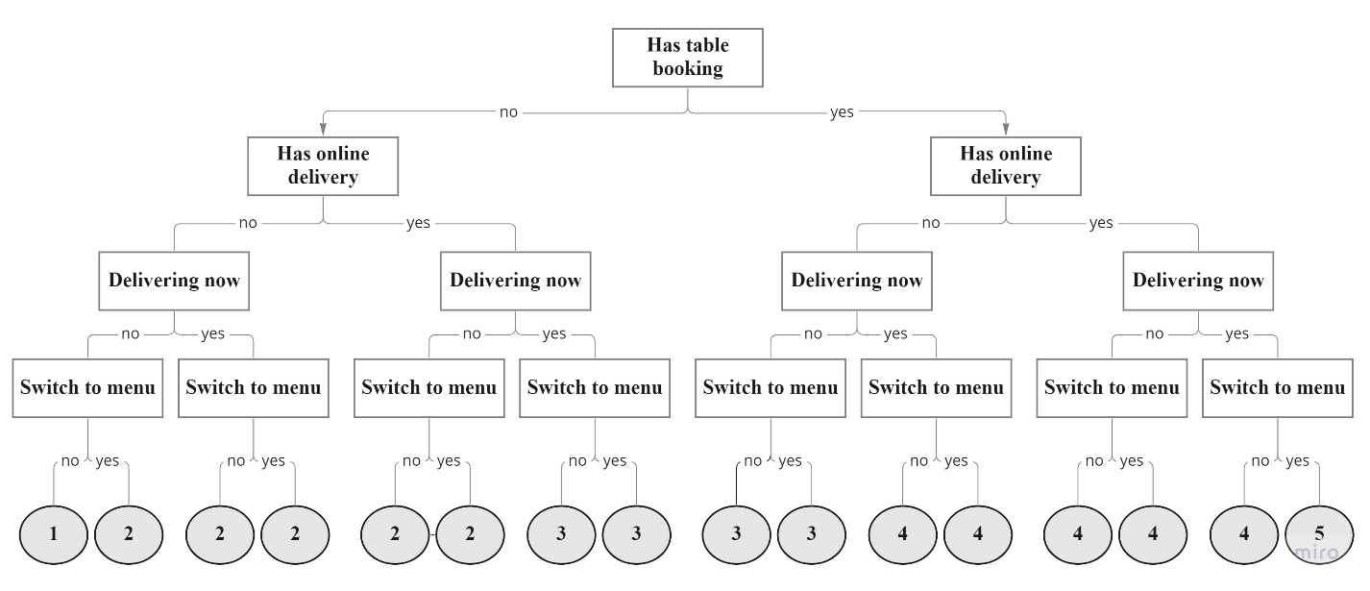

Figure . hierarchical clustering - Class Delivery-G1

### K-means clustering

One of the most used clustering techniques in data mining is K-means. n observations are separated into k clusters in K-means clustering, and each observation is assigned to the cluster with the closest mean [19]. K-means is essential to the data analyst for two reasons: differentiating by a simple pattern and running on multi-class data [20] and determining the final number of clusters.

This paper uses the ELBOW method [21] to determine the number of optimal clusters, which yields 13 optimal cluster numbers for the data set [21].

This method is a visual approach and common heuristic in mathematical optimization that the cost of clusters is calculated by beginning with K=2 and increasing it by one at each step. The cost drops dramatically after a specific value for K and then reaches a plateau when it is increased further. This point means adding another cluster after that will not significantly enhance the modeling of the data. In ELBOW, this is the selected value for K.

In the second group, k-means clustering was used. This algorithm uses non-random initial point selection and thirteen classes. Also, algorithm repetitions set twenty. This algorithm helps determine the number of classes needed.

## Oversampling

Classification systems are often faced with the challenge of learning from unbalanced datasets. Therefore, over- and under-sampling strategies are used in data analysis to fix the unstable dataset issue [22]. The Synthetic Minority Oversampling Technique (SMOTE) [23] is applied in this paper.

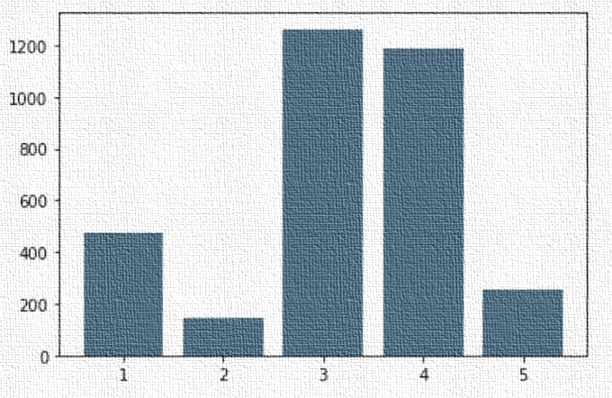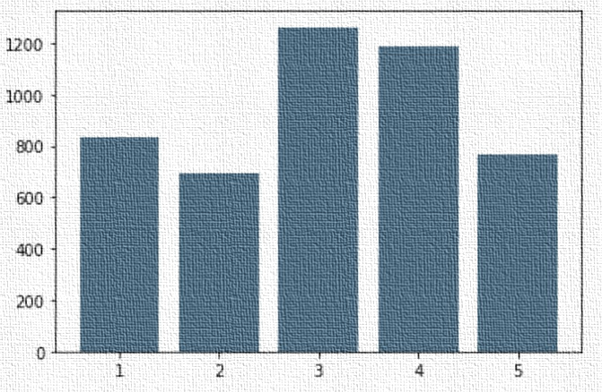As shown in Figure 3, the user rating data has a strong distribution around value 3; this causes the algorithm to deviate, ignore other data, and make incorrect predictions [24]. However, Figure 3 shows the new oversampled data set. The number of data samples in class 3 (as a maximum) did not change; however, class 2 (as a minimum) increased to 45% of class 3. Then the number of other data (with rates 1, 4, and 5) is determined based on their ratio since the data value that was more than the other still stays more, and its ratio maintains to some extent.

Figure -A. Number of data before increasing sampling based on five user rating groups

Figure -B. Number of data after increasing sampling based on five user rating groups

## Feature Selection

The augmented and oversampled dataset is then processed using the feature selection process to select the most valuable features for classification. As a result of feature selection, the data dimensions are reduced, their visualization is facilitated, and models are generally more accurate [25, 26].

In this paper, the Sequential Feature Selection (SFS) is applied in the forward direction, and six out of ten variables are returned, including "Has table booking", "Cuisine", "Price range", "Votes", "Delivery" and "Quality & Price".

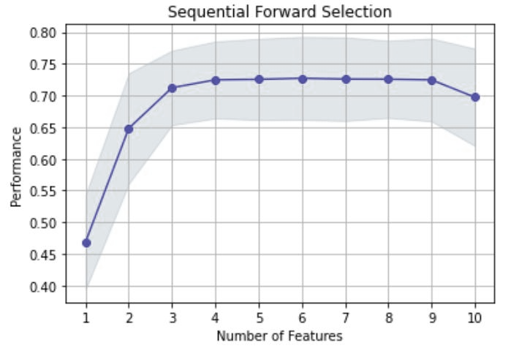The SFS method begins with the fixed parameters "Quality & Price" and "Delivery." At each step, it adds the parameter with the strongest correlation to the set of chosen features and uses supervised learning to evaluate its performance. Lastly, as shown in Figure 4. performance of feature selection, the chart ascends before selecting the sixth feature. Afterward, it descends, so the best performance depends on how six attributes are chosen.

Figure . performance of feature selection

## Supervised Classification by Random Forest Method

After clustering the dataset, classification algorithms use the aggregate rating as their output target and newly extracted features like Delivery-G1, Quality & Price-G2, and older features [17] as inputs.

The kappa score is a criterion that can better express the performance of multi-class algorithms when calculating their average accuracy. Equations 2 and 3 represent the multi-class classification accuracy [27] and the kappa score [28].

Equation

Equation

True positive (TP): correct optimistic prediction

False positive (FP): incorrect optimistic prediction

True negative (TN): correct pessimistic prediction

False negative (FN): incorrect pessimistic prediction

"For k categories, N observations to categorize and the number of times the rater i predicted category k" [29]:

Equation

Equation

Accuracy by itself cannot show how well a method performs, particularly when there are multi-classes of data, and the True Negative is ignored, so is the calculated kappa score.

The table below shows the reason for using Random Forest and compares its results with other methods.

Table . Performance of supervised learning classification

|  |  |
| --- | --- |
| *Supervised Classification Method* | *Kappa Score* |
| Random Forest | 63% |
| Support Vector Machine (Kernel: RBF) | 38% |
| Support Vector Machine (Kernel: Linear) | 28% |
| K Nearest Neighbors | 55% |
| Decision Tree | 58% |
| Naive Bayes | 35% |

The random decision forests algorithm [30] is categorized as a pattern recognition algorithm for supervised classification in machine learning and ensemble learning. The propensity of decision trees to overfit their training set is corrected by random decision forests with the class most trees choose [31]. A random forest is a collection of tree predictors incorporating certain decision trees using adaptive bagging methods [32].

In order to construct the classification model, we used labeled data from the clustering model [33] and previous basic features [17] derived from the feature selection process.

Each time a new sample is added to the sample set, the distance between the new unlabeled example and cluster centers is calculated. The trained classifier can be used without change because the unlabeled example is in the same feature space as the training examples [17].

# Results & Discussion

## check the confusion matrix

This paper has used the 3324 unique rows of the Zomato Data Set obtained from the Kaggle data repository. Use both feature selection and oversampling to achieve the best results from classification. The data set after oversampling is divided into a 30% testing set and a 70% training set for random forest classification.

Table 3 displays the results from the confusion matrix for predictions made by restaurants.

Table confusion matrix of restaurants with delivery

|  |  |  |  |  |  |  |
| --- | --- | --- | --- | --- | --- | --- |
| True label | Class 1 | 245 | 0 | 0 | 0 | 0 |
| Class 2 | 0 | 146 | 43 | 7 | 11 |
| Class 3 | 0 | 28 | 241 | 96 | 13 |
| Class 4 | 0 | 7 | 96 | 218 | 41 |
| Class 5 | 0 | 2 | 14 | 44 | 173 |
|  | Class 1 | Class 2 | Class 3 | Class 4 | Class 5 |
|  | Predicted Label | | | | |
| Accuracy | 71.7% |  |  |  |  |  |
| F1-Score | 73% |  |  |  |  |  |

After the training, testing, and oversampling, 1425 data were looked at in the testing phase. The number of system faults is shown in the above table in the form of a matrix [34]. Each row of the matrix indicates the number of actual cases, and each column indicates the number of predicted cases [35]. The number of the numbers on the matrix's diagonal equals the number of accurate forecasts made without any mistakes.

## Improvement

* The above table indicates that most detection errors occur when desired class is detected as a neighbor class. Because of the closeness of the adjacent classes in terms of the user's recommendation, it can be considered a true detection, and accuracy increases by around **96% efficiency**.

Figure . Accuracy of prediction with adjacent tags

* Compared to [5], this paper has been able to predict the future score of users in newly opened restaurants; it not only determines the ambiance of a complex but also its food delivery score. A detailed analysis of users' scores in restaurants that do not provide food delivery has also been presented, along with its impact on prediction.

## Analysis of restaurants without online ordering and delivery services

Data from Zomato's restaurant complex indicates that people rate the quality that they have received, regardless of whether a service such as delivery is available. It is evident that when this service is provided, the quality of the service will undoubtedly be impacted.

It is important to note that food quality is among the most important elements in determining customer satisfaction with online meal ordering [36, 37]. Therefore, To maintain food quality during online delivery, restaurants should evaluate their options for keeping food presentation and temperature [38].

# Conclusion

Giving ratings to service complexes is not limited to restaurants. Recommender systems can improve the audience's experience and the institution's income in any scenario.

This research has used a five-star scale. Although this classification can be done qualitatively, the numerical rate facilitates analysis.

In this research, eight of the eleven features have been used directly in predicting the performance of a restaurant will do. It is known that an algorithm in an intelligent system needs more parameters, such as service speed, food volume, etc., to work better.

Of course, eating in various locations can have different effects due to cultural differences.

# References

[1] J. A. Konstan and J. Riedl, "Recommender systems: from algorithms to user experience," *User modeling and user-adapted interaction,* vol. 22, no. 1, pp. 101-123, 2012.

[2] S. Kumar, B. Hooi, D. Makhija, M. Kumar, C. Faloutsos, and V. Subrahmanian, "Rev2: Fraudulent user prediction in rating platforms," in *Proceedings of the Eleventh ACM International Conference on Web Search and Data Mining*, 2018, pp. 333-341.

[3] P. Liu and E. C.-Y. Tse, "Exploring factors on customers’ restaurant choice: an analysis of restaurant attributes," *British Food Journal,* 2018.

[4] T. Limsarun, A. Navavongsathian, B. Vongchavalitkul, and N. Damrongpong, "Factors Affecting Consumer's Loyalty in Food Delivery Application Service in Thailand," *The Journal of Asian Finance, Economics, and Business,* vol. 8, no. 2, pp. 1025-1032, 2021.

[5] N. F. AL-Bakri, A. F. Al-zubidi, A. B. Alnajjar, and E. Qahtan, "Multi label restaurant classification using support vector machine," *Periodicals of Engineering and Natural Sciences,* vol. 9, no. 2, pp. 774-783, 2021.

[6] M. N. Varatharajan, J. Guruprasad, and K. Mathumitha, "Restaurant Recommendation System Using Machine Learning," *International Educational Applied Research Journal,* vol. 4, no. 3, pp. 1-4, 2020.

[7] J. Ha and S. S. Jang, "Effects of service quality and food quality: The moderating role of atmospherics in an ethnic restaurant segment," *International journal of hospitality management,* vol. 29, no. 3, pp. 520-529, 2010.

[8] Y. Namkung and S. Jang, "Does food quality really matter in restaurants? Its impact on customer satisfaction and behavioral intentions," *Journal of Hospitality & Tourism Research,* vol. 31, no. 3, pp. 387-409, 2007.

[9] K. Ryu and H. Han, "Influence of the quality of food, service, and physical environment on customer satisfaction and behavioral intention in quick-casual restaurants: Moderating role of perceived price," *Journal of Hospitality & Tourism Research,* vol. 34, no. 3, pp. 310-329, 2010.

[10] D. Suhartanto, M. Helmi Ali, K. H. Tan, F. Sjahroeddin, and L. Kusdibyo, "Loyalty toward online food delivery service: the role of e-service quality and food quality," *Journal of foodservice business research,* vol. 22, no. 1, pp. 81-97, 2019.

[11] J. M. Sulek and R. L. Hensley, "The relative importance of food, atmosphere, and fairness of wait: The case of a full-service restaurant," *Cornell Hotel and Restaurant Administration Quarterly,* vol. 45, no. 3, pp. 235-247, 2004.

[12] S.-S. Cha and B.-K. Seo, "The effect of food delivery application on Customer Loyalty in Restaurant," *Journal of Distribution Science,* vol. 18, no. 4, pp. 5-12, 2020.

[13] M. Haghighi, A. Dorosti, A. Rahnama, and A. Hoseinpour, "Evaluation of factors affecting customer loyalty in the restaurant industry," *African Journal of Business Management,* vol. 6, no. 14, pp. 5039-5046, 2012.

[14] Z. Zhang, Q. Ye, Z. Zhang, and Y. Li, "Sentiment classification of Internet restaurant reviews written in Cantonese," *Expert Systems with Applications,* vol. 38, no. 6, pp. 7674-7682, 2011.

[15] Y. Luo and X. Xu, "Predicting the helpfulness of online restaurant reviews using different machine learning algorithms: A case study of yelp," *Sustainability,* vol. 11, no. 19, p. 5254, 2019.

[16] S. MEHTA. "Zomato Restaurants Data." Kaggle. <https://www.kaggle.com/datasets/shrutimehta/zomato-restaurants-data> (accessed.

[17] M. Piernik and T. Morzy, "A study on using data clustering for feature extraction to improve the quality of classification," *Knowledge and Information Systems,* vol. 63, no. 7, pp. 1771-1805, 2021.

[18] F. Nielsen, "Hierarchical clustering," in *Introduction to HPC with MPI for Data Science*: Springer, 2016, pp. 195-211.

[19] A. Moore, "K-means and Hierarchical Clustering," ed: USA, 2001.

[20] Z. Yu, Q. Wang, Y. Fan, H. Dai, and M. Qiu, "An improved classifier chain algorithm for multi-label classification of big data analysis," in *2015 IEEE 17th International Conference on High Performance Computing and Communications, 2015 IEEE 7th International Symposium on Cyberspace Safety and Security, and 2015 IEEE 12th International Conference on Embedded Software and Systems*, 2015: IEEE, pp. 1298-1301.

[21] R. L. Thorndike, "Who belongs in the family," in *Psychometrika*, 1953: Citeseer.

[22] G. Lemaître, F. Nogueira, and C. K. Aridas, "Imbalanced-learn: A python toolbox to tackle the curse of imbalanced datasets in machine learning," *The Journal of Machine Learning Research,* vol. 18, no. 1, pp. 559-563, 2017.

[23] N. V. Chawla, K. W. Bowyer, L. O. Hall, and W. P. Kegelmeyer, "SMOTE: synthetic minority over-sampling technique," *Journal of artificial intelligence research,* vol. 16, pp. 321-357, 2002.

[24] G. Douzas and F. Bacao, "Effective data generation for imbalanced learning using conditional generative adversarial networks," *Expert Systems with Applications,* vol. 91, pp. 464-471, 2018.

[25] H. Liu, "Feature Selection," in *Encyclopedia of Machine Learning*, C. Sammut and G. I. Webb Eds. Boston, MA: Springer US, 2010, pp. 402-406.

[26] S. Solorio-Fernández, J. A. Carrasco-Ochoa, and J. F. Martínez-Trinidad, "A review of unsupervised feature selection methods," *Artificial Intelligence Review,* vol. 53, no. 2, pp. 907-948, 2020.

[27] M. Grandini, E. Bagli, and G. Visani, "Metrics for multi-class classification: an overview," *arXiv preprint arXiv:2008.05756,* 2020.

[28] J. Cohen, "A coefficient of agreement for nominal scales," *Educational and psychological measurement,* vol. 20, no. 1, pp. 37-46, 1960.

[29] S. Collazo, M. Barrucand, and M. Rusticucci, "Association between El Niño and extreme temperatures in southern South America in CMIP5 models. Part 1: model evaluation in the present climate," *Climate Research,* vol. 83, pp. 111-132, 2021.

[30] T. K. Ho, "Random decision forests," in *Proceedings of 3rd international conference on document analysis and recognition*, 1995, vol. 1: IEEE, pp. 278-282.

[31] T. K. Ho, "The random subspace method for constructing decision forests," *IEEE transactions on pattern analysis and machine intelligence,* vol. 20, no. 8, pp. 832-844, 1998.

[32] L. Breiman, "Random forests," *Machine learning,* vol. 45, no. 1, pp. 5-32, 2001.

[33] A. F. Hassan, "Using Unlabeled Data Set for Mining Knowledge from DDB," *Jurnal Ilmiah Teknik Elektro Komputer dan Informatika (JITEKI),* vol. 7, no. 1, pp. 1-8, 2021.

[34] S. V. Stehman, "Selecting and interpreting measures of thematic classification accuracy," *Remote sensing of Environment,* vol. 62, no. 1, pp. 77-89, 1997.

[35] D. M. Powers, "Evaluation: from precision, recall and F-measure to ROC, informedness, markedness and correlation," *arXiv preprint arXiv:2010.16061,* 2020.

[36] H. H. Abdelhamied, "Customers' perceptions of floating restaurants in Egypt," *Anatolia–An International Journal of Tourism and Hospitality Research,* vol. 22, no. 01, pp. 1-15, 2011.

[37] M. R. Jalilvand, S. Salimipour, M. Elyasi, and M. Mohammadi, "Factors influencing word of mouth behaviour in the restaurant industry," *Marketing Intelligence & Planning,* 2017.

[38] K. Annaraud and K. Berezina, "Predicting satisfaction and intentions to use online food delivery: What really makes a difference?," *Journal of Foodservice Business Research,* vol. 23, no. 4, pp. 305-323, 2020.